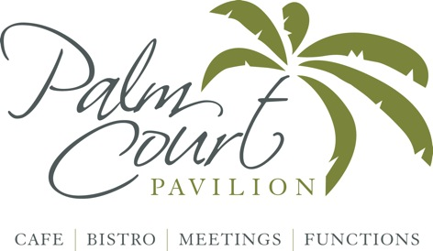

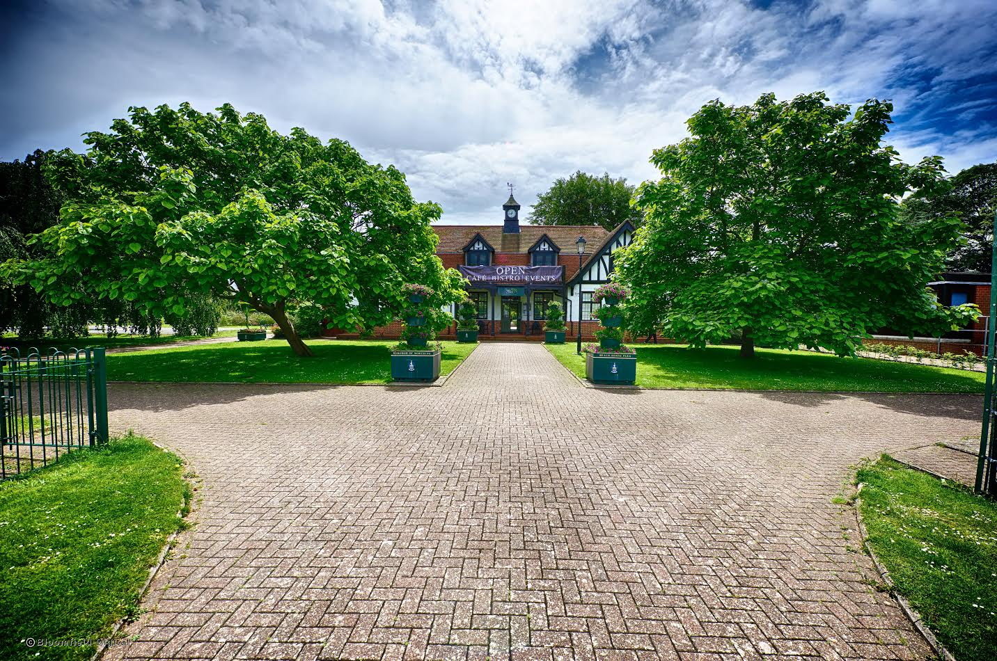

**Function Information & Menus**



**About us**

Nestled in Worthing’s stunning Beach House Park, Palm Court Pavilion is a stylish,

beautifully renovated café-bistro in the park’s Old Pavilion. Located just minutes from

the town centre and the seafront, Palm Court Pavilion serves delicious homemade food

and has a range of options for functions and events.

The cafe is an exciting new chapter in the Pavilion’s interesting history; after some years

in disuse, the Pavilion has been given a new lease of life. The landmark building has been

sympathetically renovated, emphasising the natural light and an extensive outdoor decking

area makes the most of the beautiful park setting. Both areas of decking can be used for

private parties.

The upstairs function room has a balcony giving delightful views of the park and bowling

greens, a perfect venue for parties, meetings and events.

The outside space in the park can also be used for larger scale events of up to 1000 people,

ideal for weddings, dining, exhibitions, corporate launches, markets and roadshows.

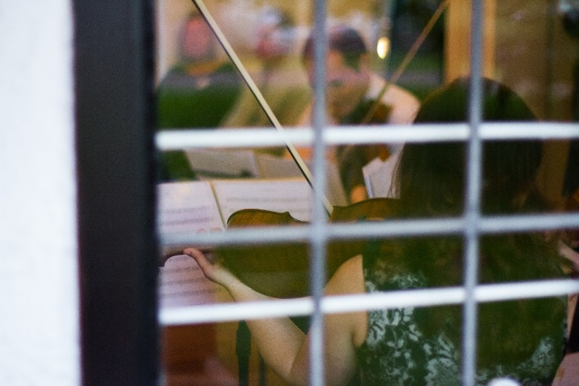

**Room Capacity & Rates**

|  |  |  |  |  |  |  |  |
| --- | --- | --- | --- | --- | --- | --- | --- |
| **Room** | **Park View Room** | **Palm Court** | | **Beech Terrace** | | **Maple Terrace** | **External Marquee** |
| **Daytime – 9am- 5pm**  Monday - Friday  Saturday & Sunday | £200 -£250*  £250* | On request  On request* | | £250*  £250* | | On request | On request |
| **Evening - 7pm-10pm**  Monday -Friday  Saturday & Sunday | £50 – £100*  £250* | On request  On request | | £150*  £250* | | On request | On request |
| **Maximum Capacity** |  | | | | | | |
| Board Room | 36 | n/a | n/a | | n/a | | On request |
| Theatre | 60 | n/a | n/a | | n/a | | On request |
| Dining | 40 | 70 | 75 | | 90 | | 75 - 1000 |
| Buffet | 60 | 100 | 120 | | 150 | | On request |

* Prices depend on numbers & menu chosen and will vary by season exclusive of VAT

** Park View Room has a ceiling mounted HDMI Projector for hire.

*** Jan-February lower winter rates apply please call to discuss

Marquee available to hire throughout June and July 2017 call for rates

Sole use of all of the Palm Court is also available upon request

**Parking**

Ample parking available (pay & display every day 8am – 6pm)

Free after 6pm vouchers available for groups

Disabled parking available upon request

**Park View Room**

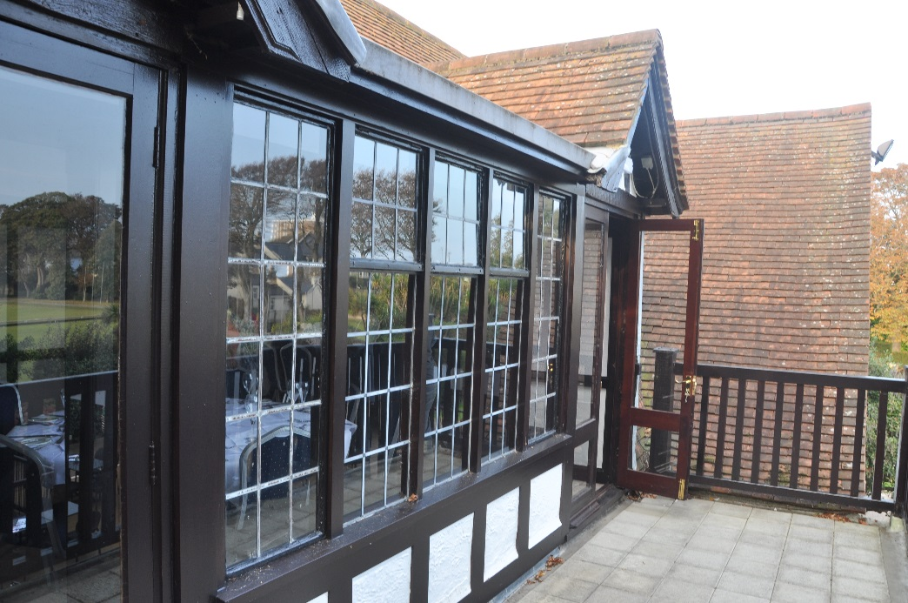

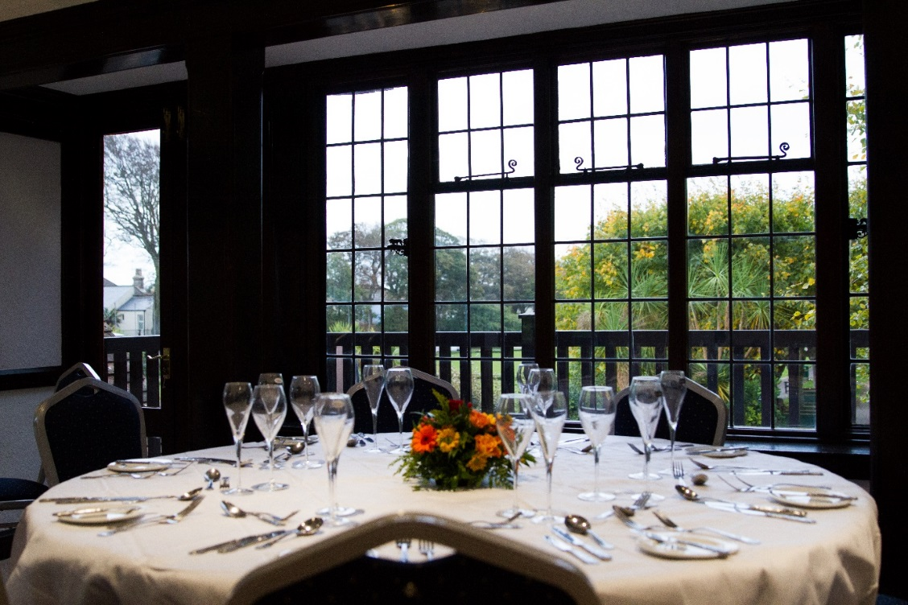

**Palm Court**

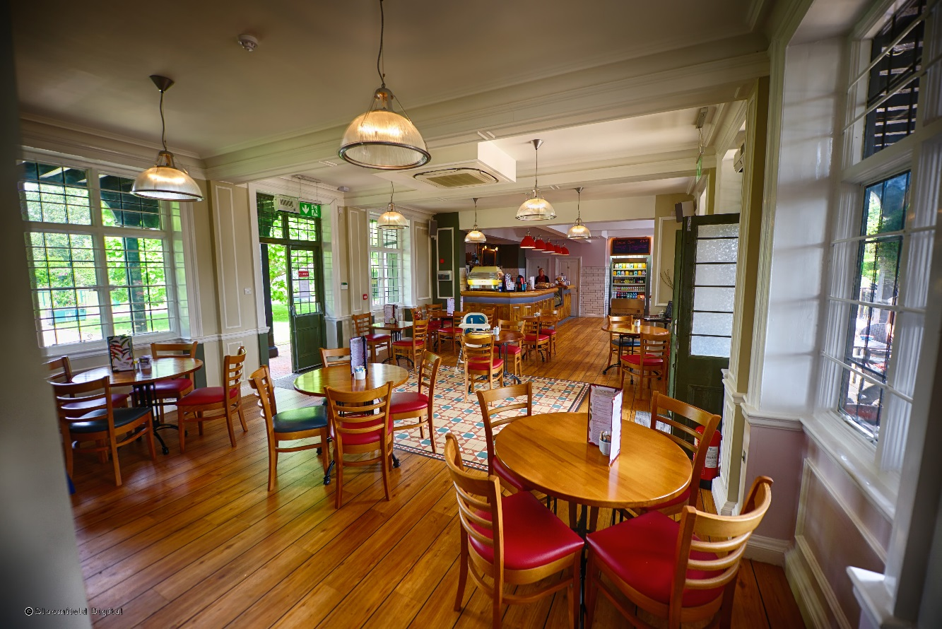

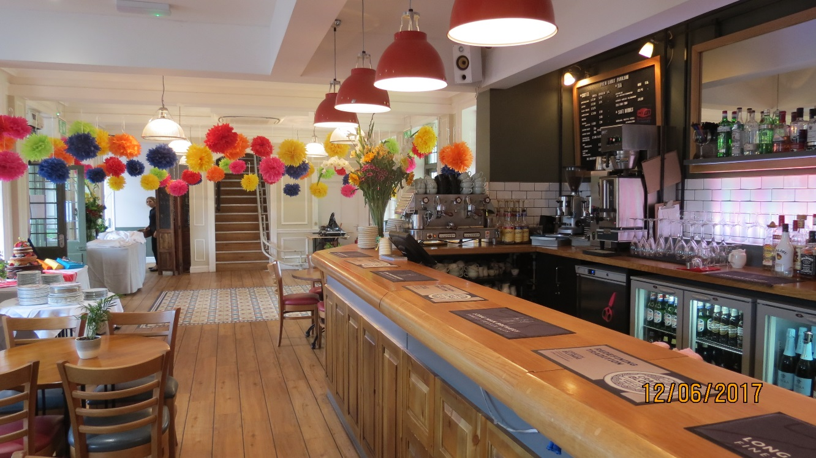

**Maple Terrace**

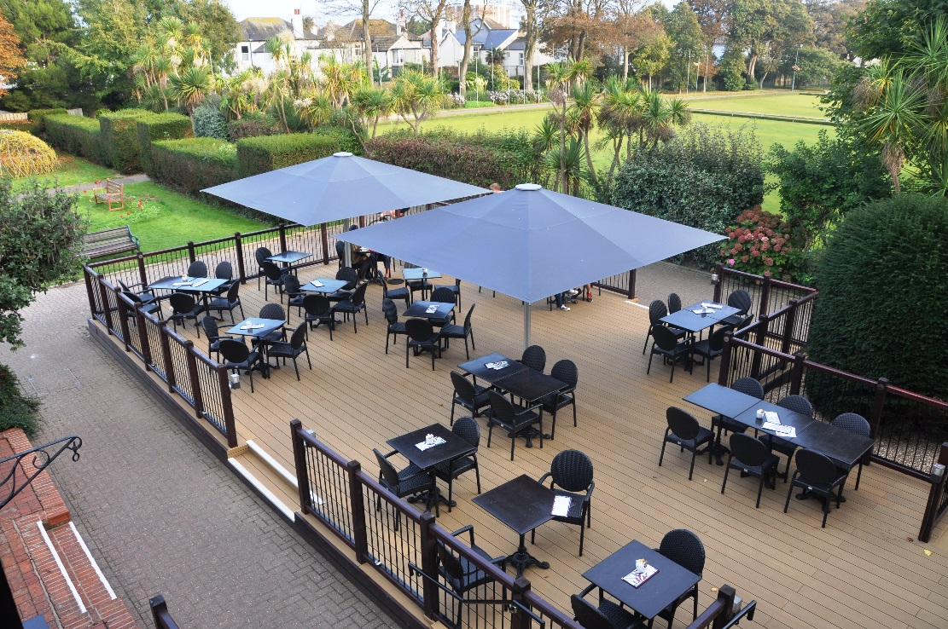

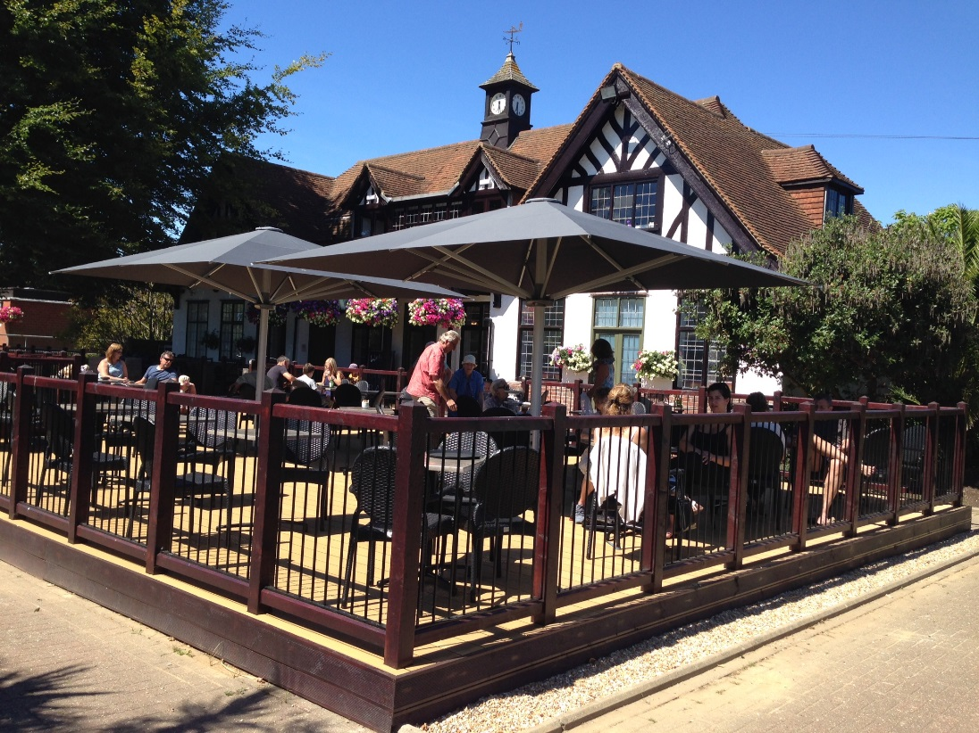

**Beech Terrace**

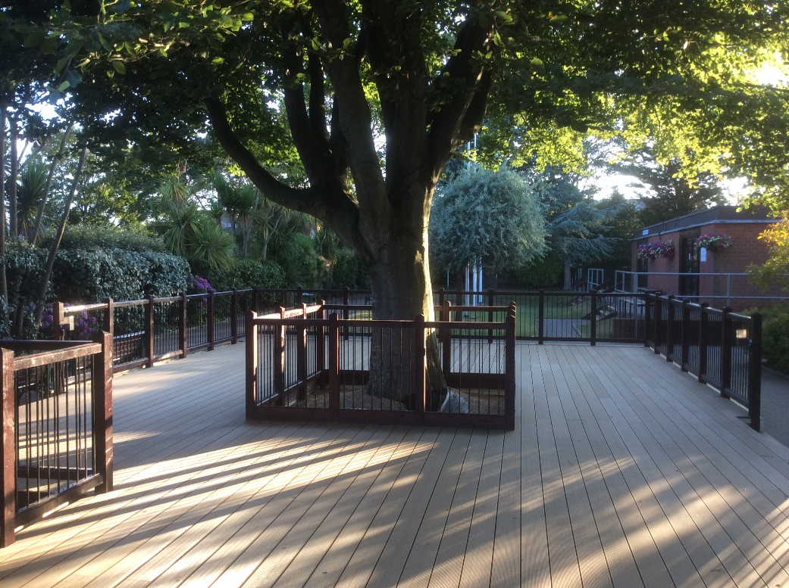

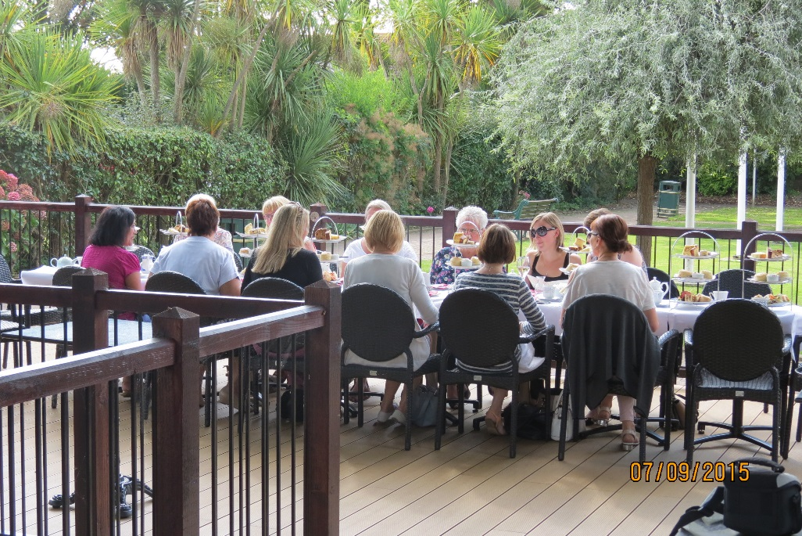

**External Marquee**

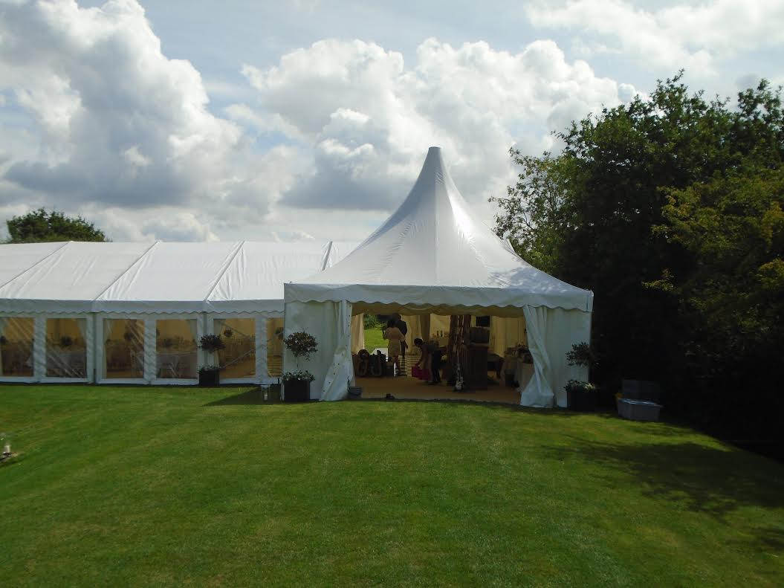

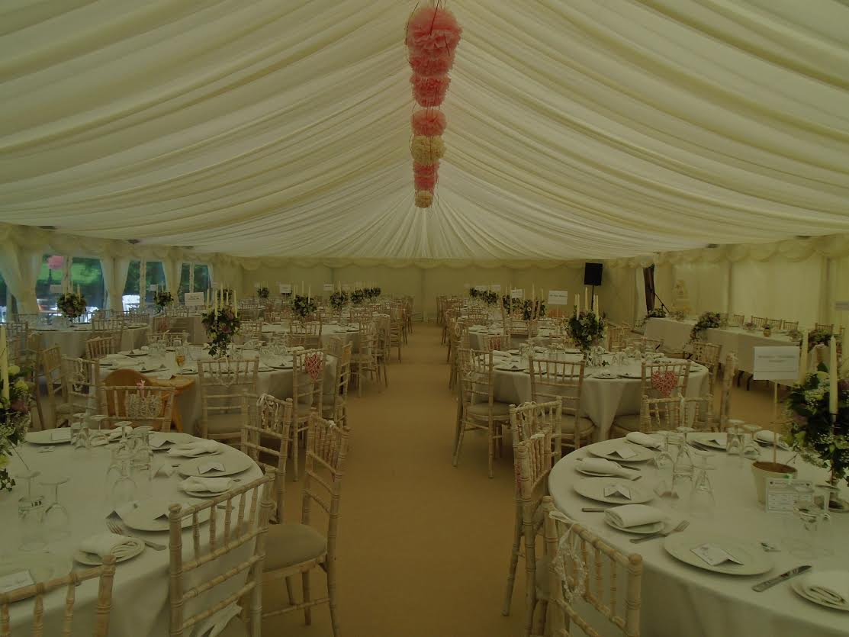

**Banqueting Menu**

**2 Courses from £25.00**

**3 Courses from £29.95**

**Starters**

Classic prawn cocktail with a sweet paprika marie rose sauce

Lobster tail and avocado salad with a tangy salad dressing (£2 supplement)

Roasted butternut squash and cumin soup topped with a light mixed herb oil,

with chunky focaccia

Bruschetta with marinaded tomatoes and feta cheese with rocket salad

Galia melon, carved and filled with a variety of exotic tropical fruit (£1 supplement)

Homemade chicken liver pate with fruit chutney and toasted bread

Breaded brie deep fried with salad leaves and an apricot & apple sauce

Mozzarella and tomato salad with a fresh basil dressing

Warm duck breast and orange salad with herb salad and a plum dressing (£1.50 supplement)

**Main Courses**

Roast beef with Yorkshire pudding and rich jus

Roast chicken with mini stuffing parcels and chipolata sausages

Scottish salmon fillet oven roasted with a garlic and pesto crust

Roasted Monkfish fillet wrapped in parma ham with a black olive and lemon mash (£2.00)

Chicken Breast stuffed with sun blush tomato pesto wrapped in Parma ham

Pork Loin pan fried with a rich mushroom and brandy sauce

Herb crusted rack of lamb, served with a redcurrant and mint jus (£2.00)

Beef Wellington, prime fillet beef with pate in puff pastry and a madeira wine jus (£2.50)

Portabello mushroom, spinach & blue cheese en croute

Vegetable hot pot with seasonal vegetables and homemade herby dumplings

**Desserts (all homemade)**

Sharp Lemon Tart with redcurrants and crème fraiche

Raspberry and white chocolate cheesecake

Warm Chocolate Brownie with clotted cream

Individual strawberry pavlova

Bakewell tart with creme Anglaise

Apple and summer fruit crumble with custard

Eton Mess

Chocolate profiteroles with fresh cream

Cheeseboard, selection of four cheeses with water biscuits and chutney (£2 supplement)

Prices based on minimum numbers please enquire for your event and a maximum choice of 3 items from each section all mains served with seasonal vegetables



**Canape Menu**

**Cold Canapés**

Smoked salmon & horseradish cream on blini

Pear, stilton & walnut (v)

Coronation chicken on mini naan

Melon & feta skewers (v)

Chicken liver parfait with onion marmalade

Smoked salmon in brioche with dill cream cheese

Wild mushroom crostini (v)

Mozzarella, tomato and basil skewer (v)

**Hot Canapés**

Sweet potato frittata (v)

Tomato & feta tartlet (v)

Mini goat cheese parcel (v)



Pork and apple sausage rolled in puff pastry

Breaded brie

Bacon wrapped asparagus

Mini beef and horseradish

**£9.50 per person (5 items) £12.50 per person (7 items)**

**Drinks Packages**

**Pimm’s no. 1 Reception: £5.25 per person**

One welcome drink per guest of classic Pimm’s plus a selection of beers and soft drinks as an alternative

**Prosecco Reception: £5.45 per person**

One welcome drink per guest plus a selection of beers and soft drinks as an alternative

**Champagne Reception: £7.50 per person**

One welcome drink per guest plus a selection of beers and soft drinks As an alternative

**Pavilion Package A: £14.50 per person**

½ bottle of house wine, glass of prosecco for the toast

Or

Pimms or prosecco reception drink, ½ bottle of house wine

**Pavilion Package B: £19.50**

Pimms or prosecco reception drink, ½ bottle of house wine, glass of prosecco for toast

**Evening Finger Buffet Menu**

Selection of filled bridge rolls and sandwiches on artisan breads

Selection of chicken skewers

Scotch eggs with piccalilli

Smoked salmon and cream cheese bagels

Frittata with baked butternut squash

Potato wedges

Selection of mini quiche slices

Chinese prawn gyozas with ginger

Selection of bhajis, pakoras and samosas with mango chutney

Pigs in blankets (chipolata wrapped in bacon)

**3 items £12.50; 6 items £15.00; 9 items £19.95 -**minimum numbers apply

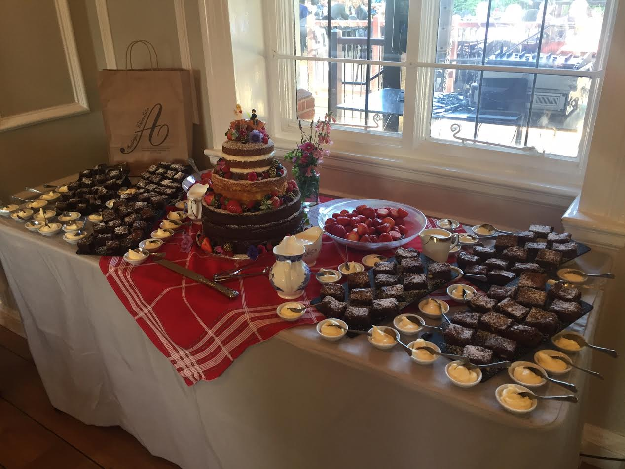

**Cold Buffet Menu**

**Menu A**

Charcuterie and smoked fish platter

Roasted red pepper and halloumi salad

English cheeses with pickles and breads

Plus your choice of four salads

**£24.95**

**Menu B**

Poached salmon with lemon mayonnaise

Charcuterie and smoked fish platter

****Trio of parfait platter with meat fish and vegetarian options

Smoked ham with English relishes

Scotch egg with piccalilli and beetroot salad

Plus your choice of four salads

**£29.95**

**Salads**

Vine tomato, shaved red onion, balsamic vinegar and baby basil

Nicola potato salad, slice spring onion and creamy mayonnaise

Chargrilled vegetables, bulgur wheat, dried fruit and fresh herbs

Feta cheese, melon and mint

Seasonal leaves

Beetroot coleslaw and fresh herbs

Penne pasta salad with olive garlic basil and tomato

**Daytime events**

Using a private room

Platter of sandwiches using a variety of breads

Platter of homemade cakes **£15.00** per person

**Afternoon Tea** served on a traditional tea stand

with finger sandwiches, warmed scones with clotted cream & jam

together with a selection of cakes & pastries and a pot of tea **£15.00** per person

Add a glass of prosecco **£5.25**

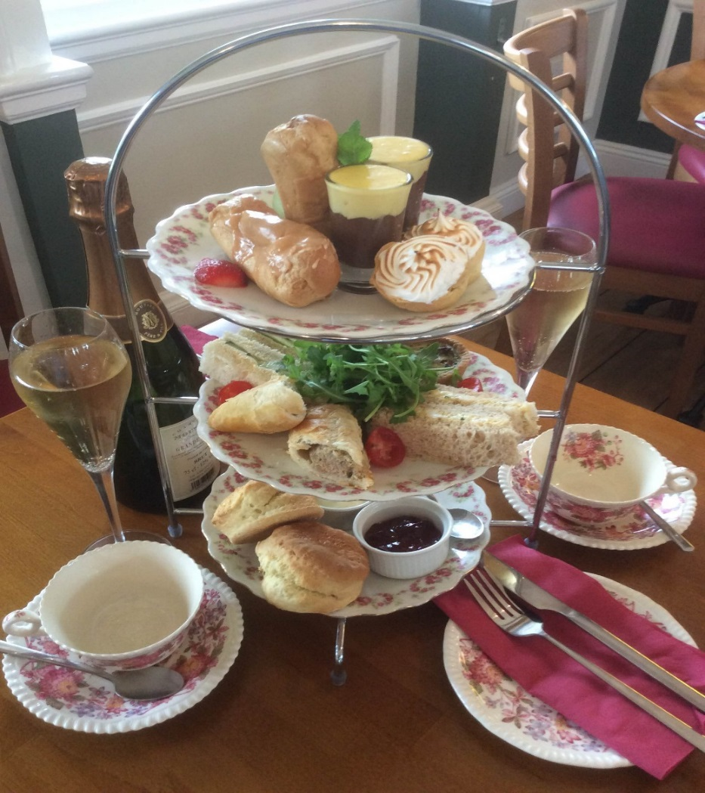

Subject to availability Afternoon tea packages can be tailored to your needs

We can add a range of cocktails and can also theme to requirements minimum numbers apply

**Street Food**

**Barbeque**

Chicken kebabs marinated in lime & ginger

Handmade beef burger

Butchers sausages

Spiced lamb sheek kebab

Tiger Prawn skewers marinated in chilli & garlic (£1.00 supplement)

Halloumi cheese, pepper & tomato skewers

Mixed vegetable kebabs

Chilli corn cob

Monk fish, chorizo kebab (£1.00 supplement)

Your choice of 4 items with 4 salads and baskets of bread, buns and sauces.

from **£19.50** per person- minimum numbers apply

**Paella** Minimum of 50 people

Rich, colourful, flavoursome and cooked in our huge paella pans in front of your guests, we can offer you meat, seafood and vegetarian options. You can choose ingredients such as chicken, chorizo, prawns, mussels, peppers.

Your choice of Paella

Mixed salad leaves, tomato & fresh basil, sliced cucumber, peppers and onion

from**£16.50** per person

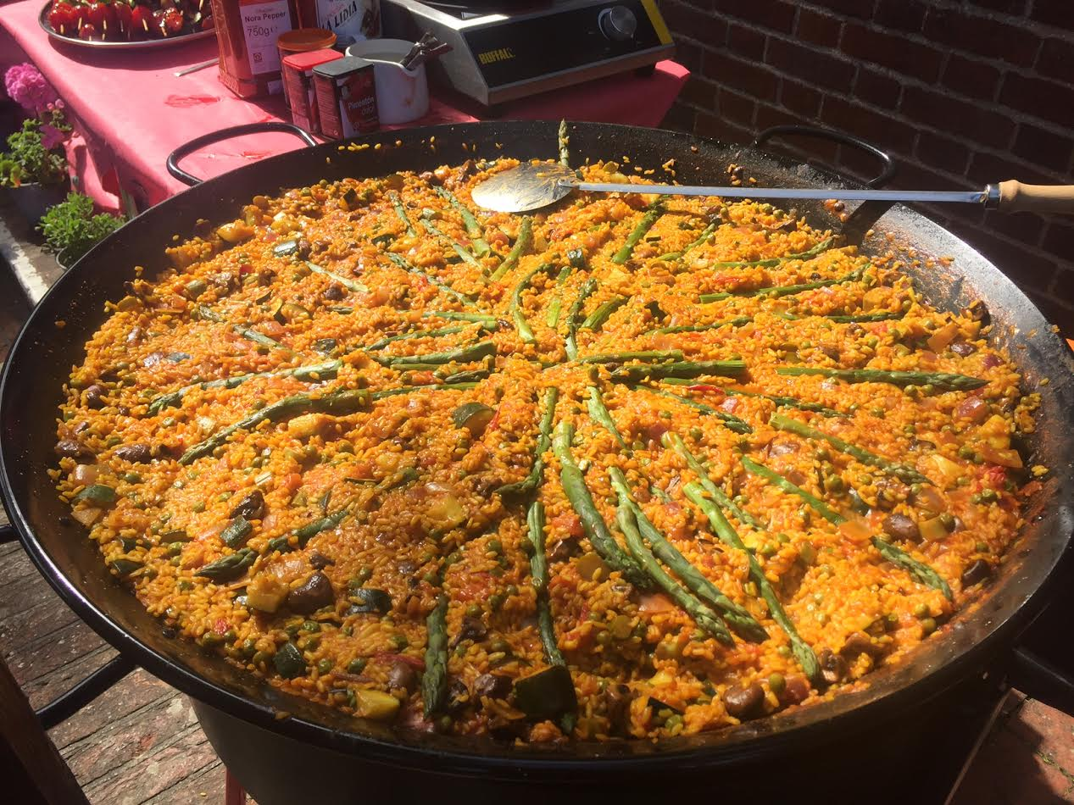

**Delegate Menu**

**Cost per head**

**Continental Breakfast Buffet**  **£6.95**

Cold meats, cheeses, pastries & rolls

Fruit juice, tea & filter coffee

**Lunch Option A £12.95**

Mixed sandwich platter

Fruit platter

**Lunch Option B £15.95**

Mixed sandwich Platter

Warm quiche and sausage rolls

**Lunch Option C £17.95**

Hot dish of the day with accompaniments

Vegetarian dish of the day available

**All menus based on a minimum number of delegates**

**Wedding Information**

Set in the beautiful Beach House Park Palm Court Pavilion gives a stunning backdrop for your special day.

We would be delighted to discuss arrangements for your day and develop a bespoke package

to suit your needs. Please arrange an informal meeting so we can start planning!

Different spaces are available, both inside and outside, depending on your numbers. A private decking area can be arranged and the Park View Room provides an ideal space for smaller groups.

Sole use of the property can be arranged for larger groups and we can organise a purpose built Marquee on the bowling green adjacent to Palm Court for a bigger event.

[](https://www.google.co.uk/url?sa=i&rct=j&q=&esrc=s&source=images&cd=&cad=rja&uact=8&ved=0ahUKEwjfg7HzxPnUAhWDJ1AKHQbdADMQjRwIBw&url=https://www.pinterest.com/jane19720063/clipart-drinks/&psig=AFQjCNH1fabNKUQqNOumKMCKpLrgYH5cXA&ust=1499598183125235)

From a sit down three course meal to a buffet or paella & barbeque on the extensive decking area we can organise the type of day and food choices you would like.

Our Chef is keen to create exciting, innovative and beautiful looking food and will work with you to develop an individual display.

Please note that Palm Court Pavilion is not licensed to perform wedding ceremonies, however you can arrange a celebrant.

**Park View Room**

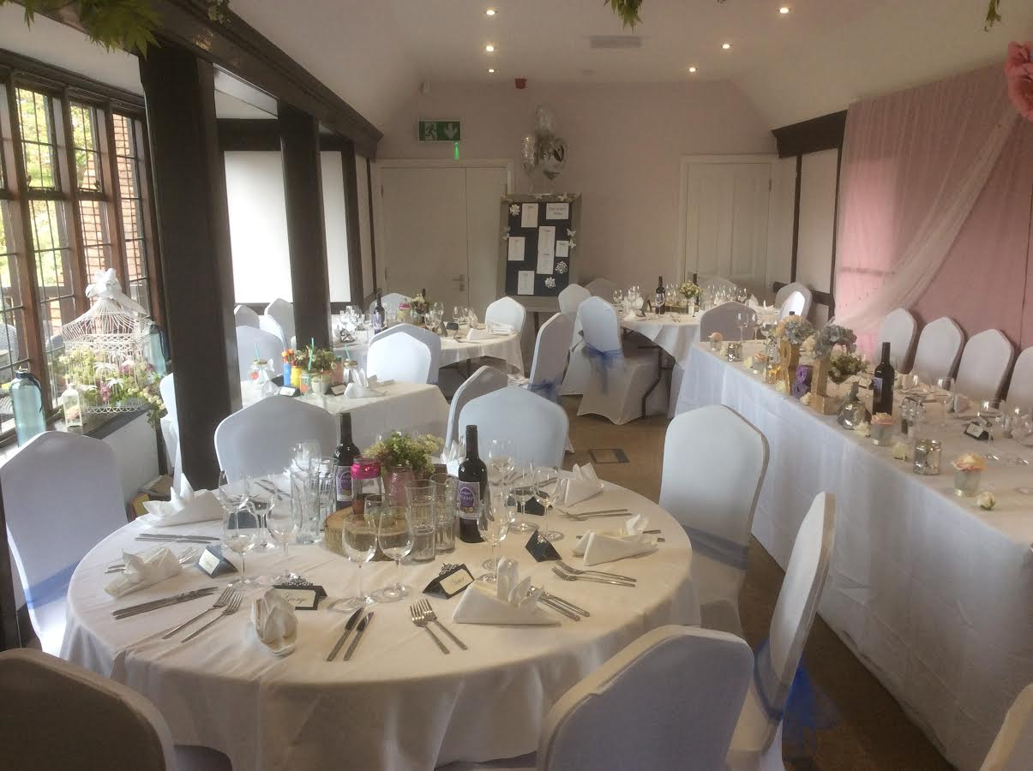

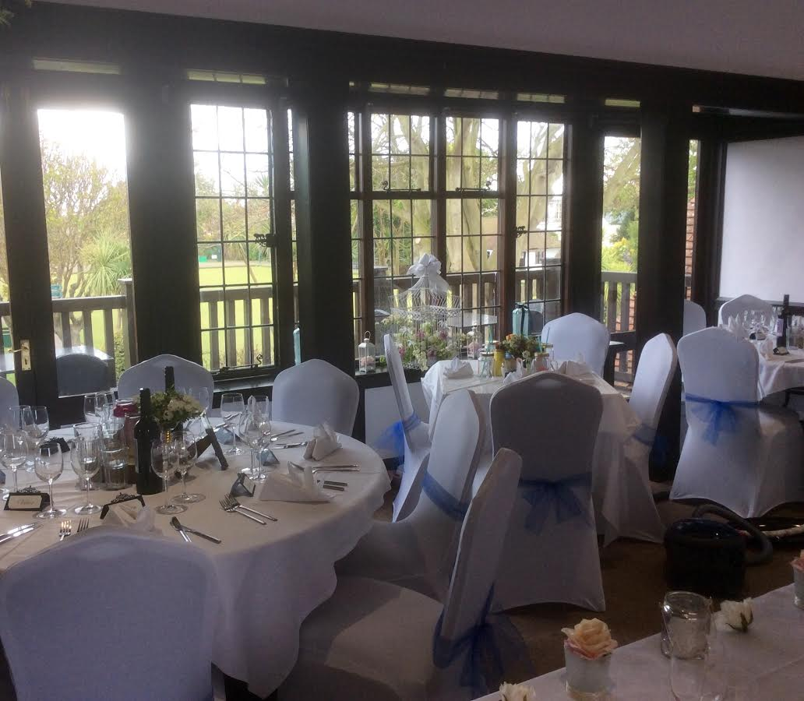

**Beach Terrace**

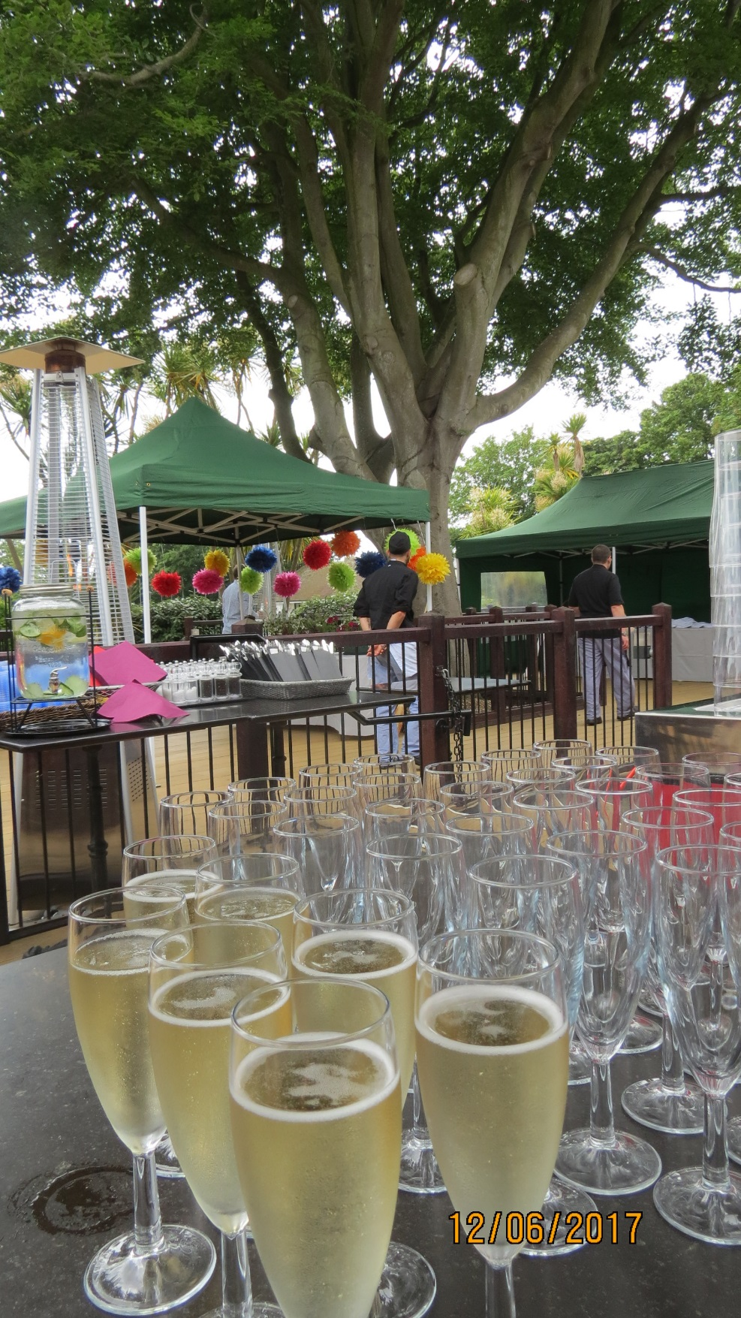

[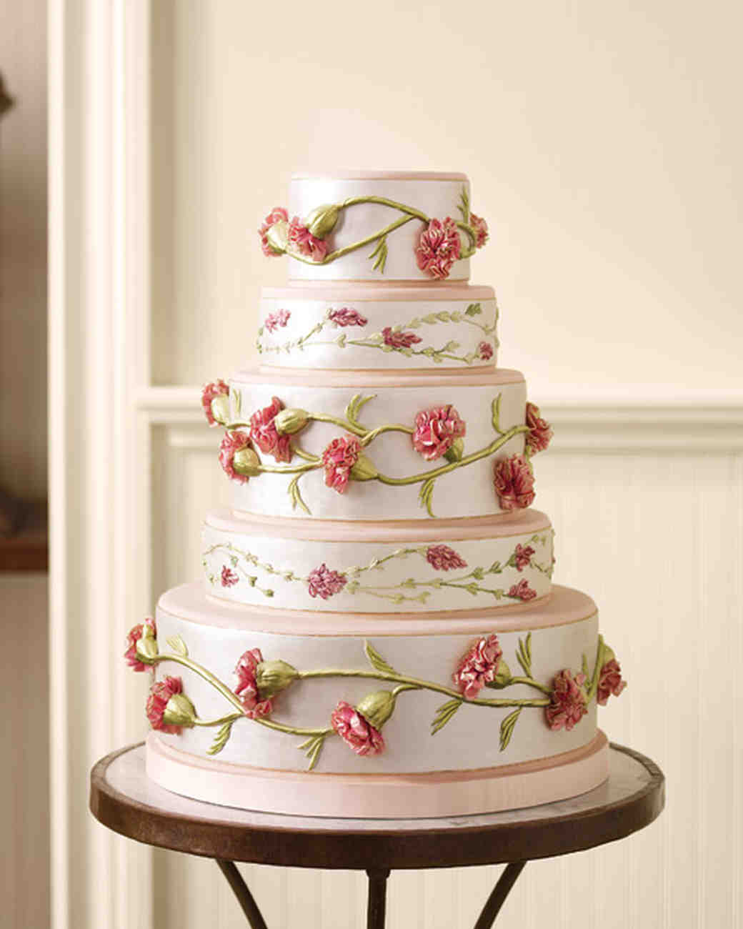](http://www.google.co.uk/url?sa=i&rct=j&q=&esrc=s&source=images&cd=&cad=rja&uact=8&ved=0ahUKEwjBxKTayvnUAhWGL1AKHVlvDyMQjRwIBw&url=http://www.marthastewartweddings.com/231265/50-great-wedding-cakes&psig=AFQjCNEjRpMvWepWDwhKNf1r6Y2HRhT9zg&ust=1499599731580109)

[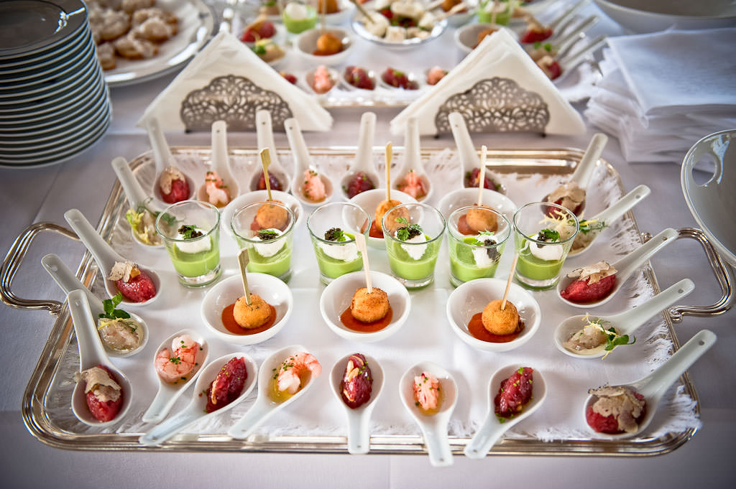](http://www.google.co.uk/url?sa=i&rct=j&q=&esrc=s&source=images&cd=&cad=rja&uact=8&ved=0ahUKEwjq96zYzPnUAhWSmbQKHUnCAIMQjRwIBw&url=http://www.distinctiveitalyweddings.com/blog/2011/09/italian-wedding-receptions-feasting-and-celebrating-italian-style/&psig=AFQjCNHyG02NRHrm8w-6oeoVLEZEYbeP5w&ust=1499599832117409)

[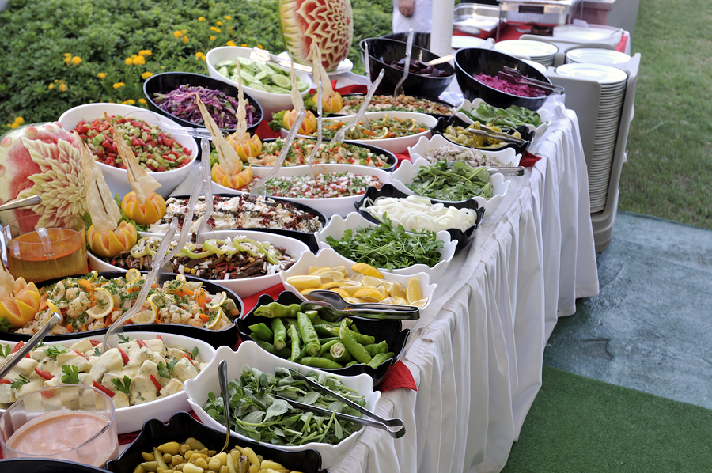](http://www.google.co.uk/url?sa=i&rct=j&q=&esrc=s&source=images&cd=&cad=rja&uact=8&ved=0ahUKEwjvtsSF__vUAhXLKlAKHbWEBvEQjRwIBw&url=http://sandwichbuffet.co.uk/2014/02/10/local-wedding-catering-london/&psig=AFQjCNHR_1bq-CovYL02x65-8PKVLhfKCg&ust=1499682552770782)

**Dessert Buffet**



**Terms & Conditions**

**VAT** All prices shown are inclusive of VAT except room hire.

**Booking and confirmation** If you wish to proceed with the booking, we will issue an invoice for a non-refundable 25% of the agreed total. The booking is not confirmed until the booking form has been returned and the 25% deposit has been received. The remaining balance, including any agreed drinks packages, is due 14 days prior to the event date. Final numbers are to be confirmed 7 days prior to the event. Any amendments to the booking must be confirmed in writing and no less than 28 days before the event.

**Cancellation** The deposit is non-refundable in the event of cancellation. If an event is cancelled less than four months prior to the scheduled date then full payment for the planned event is due.

**Access** The premises will be available at the time specified on the booking form. Access to decorate the room can be arranged during Palm Court’s normal opening times, please check with the Duty Manager.

**Decorations** Bunting, balloons and banners are welcome using blutac to secure. Mini glitter and confetti is not permitted inside or outside the building. Smoke/Bubble machines or pyrotechnics are not permitted on any part of the premises. No alterations or additions to fixtures, fittings, lighting or heating are permitted.

**Use of premises** The use of the premises must be as indicated on the booking form. Gaming is not permitted on the premises. The premises shall not be used for any illegal, immoral or other purpose that could breach any legislation or regulation, or that could jeopardise any insurance cover in respect of the premises.

**Damage** The organiser shall take all precautions to prevent damage, and shall defray the cost of making good any damage caused to the premises or any theft or loss of goods or appliances belonging to Palm Court during the event or directly connected to the event.

**Behaviour** Palm Court will not tolerate discriminatory, offensive or abusive behaviour by any group or individual, and reserves the right to terminate or cancel an event if this condition is breached. During the event, all persons on the premises must comply with any directions of the Duty Manager regarding proper use of the premises and items brought onto it. Palm Court Pavilion shall, at its absolute discretion cancel or terminate an event if damage to the venue is considered likely or has occurred in connection with the event. In such cases, the organiser shall still be liable for the full cost of the event.

**Personal property** No items are allowed or stored on any part of the premises outside the event times as detailed in the booking confirmation. All items left on the premises after an event will be deemed unwanted and disposed of without notice. Palm Court Pavilion does not accept any responsibility for damage, loss or theft of any property left on the premises at any time.

**Catering and drinks** Palm Court does not permit any external catering companies within the park. Under the terms of our license we cannot permit any persons to provide or consume any beverages (alcoholic or otherwise) that have not been purchased on the premises. We will not be held liable under any circumstance for the quality or hygiene of any self-catered food served on the premises.

**Crockery and Glassware deposit** For outdoor events a deposit of £200 will be required to cover any broken or missing china or glassware. The deposit will be refunded, less any deductions to cover broken or missing items, after the event.





